**DT529PAYOR Instructions**

For the Information Service’s Office

Created 2024

1. Open S:\it_apps\ DT529PAYOR.exe 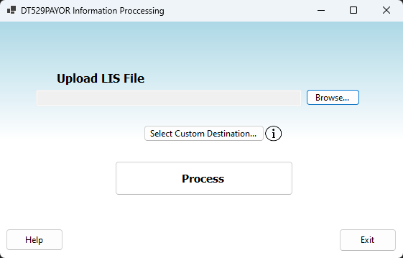
2. Click *Browse* to search for your .LIS file. You may also drag the file onto the window.

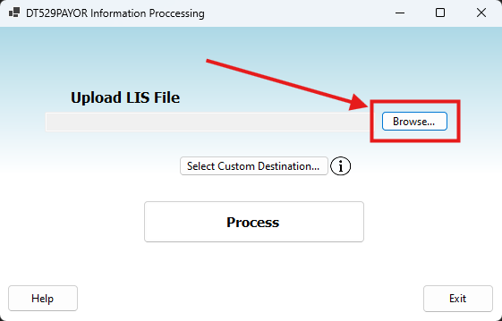

1. By default, your new .CSV file will save in the same folder that your .LIS file currently is. If you would like to change the location that the .CSV file will be saved to, click on *Select Custom Destination.* Here you can choose where you would like to save the file.

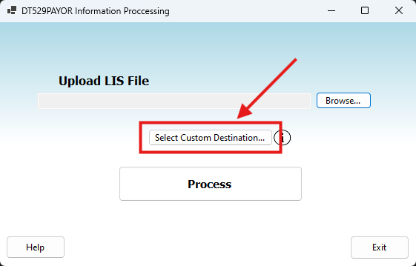

1. When a custom destination is selected, it will appear under the *Select Custom Destination* button.

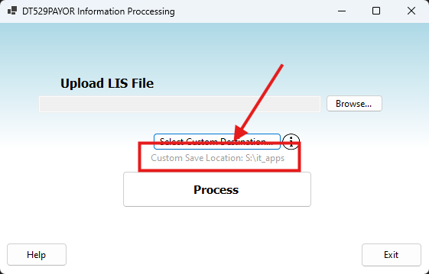

1. When a .LIS has been selected, the file path will appear in the text box.

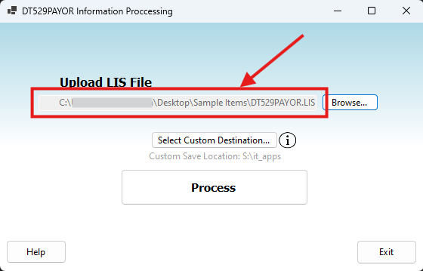

1. When you are ready, click *Process* to generate your .CSV file.

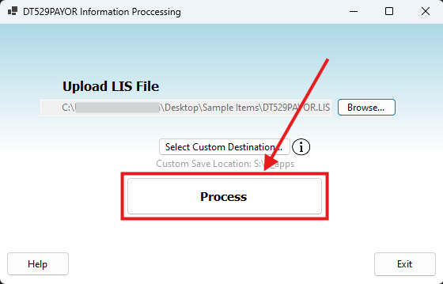

1. The file should now be created and ready for you to use. The newly created .CSV file will share the same name as the .LIS used to create it. If there was an error, make sure the file you’re uploading is a .LIS.

